Beyond the First Paycheck: Is Your College Major Worth the Debt?

- Authors: Giovanni Miquelin, Miranda Hancock, Khadeja Monshin
- Course: Math 2327 – Introduction to Data Analysis
- GitHub Repository: View Project Code & Data on GitHub(add link)
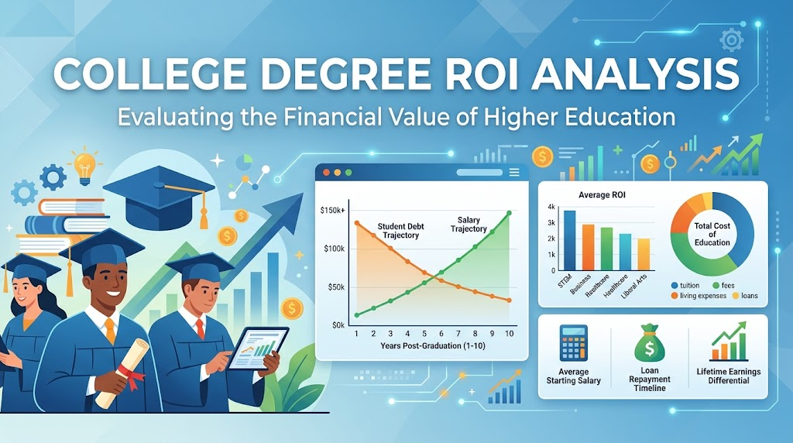

1. The Problem: Looking Beyond Starting Pay
When choosing a college major, most students look only at starting salary. However, focusing only on salary hides critical financial facts:
- Debt Varies Greatly: Student loan balances change drastically based on your major and school.
- High Pay Can Be Misleading: A high starting salary combined with extreme student debt creates long-term financial pressure.
- Industry Trajectory Matters: High pay in a shrinking field creates long-term career risks.
- Our Goal: We analyzed higher education data to find the most secure college majors and the highest-risk degree paths.

2. Introducing the Dataset & Our Data Cleaning Work
Dataset Link - Kaggle
To evaluate college degrees, we worked with a comprehensive dataset:
- Dataset Size: 227,980 U.S. college programs.
- Data Structure: Each row represents a unique combination of institution, field of study, and degree level.
- Data Cleaning & Wrangling Work:
  - Fixed Variable Names: Renamed confusing column titles and corrected improper data formatting.
  - Cleaned Missing Data: Filtered out empty NULL values so they would not distort statistical equations.
  - Managed Scale & Performance: Aggregated massive row counts to prevent computer lag and stop visualization tools (like Tableau) from crashing.

3. The Baseline: Meet "John" (The Average Student)
To compare majors, we created a profile of the statistically average U.S. college graduate:
- Major: Bachelor's Degree in Business (Public University)
- Median Student Debt: $29,500
- Year 1 Starting Pay: ~$54,000 / year
- Year 5 Mid-Career Pay: ~$88,000 / year
- Year 1 Debt-to-Earnings Ratio: 60.8%
- Average Career Growth: 8.31%
- Employment Stability: 62% likelihood of staying continuously employed

4. Comparing Majors: High Pay vs. High Risk
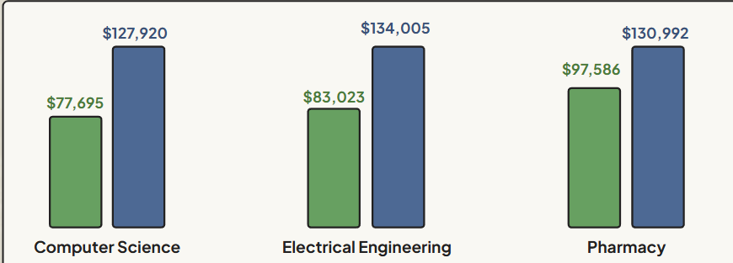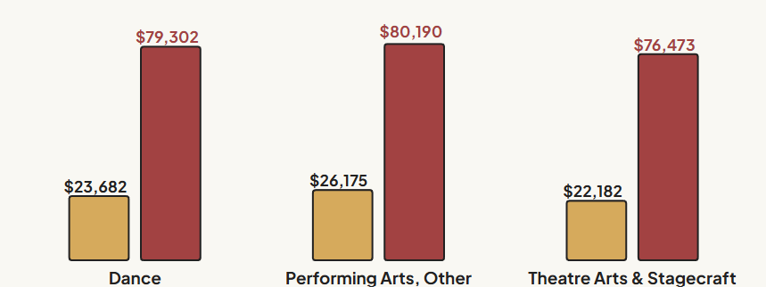

High Pay, Low Pain (The Best STEM Options)
In these majors, Year 1 earnings cover 60% to 75% of total debt right after graduation:
- Computer Science:
  - Year 1 Earnings: $77,695
  - Average Total Debt: $127,920
  - Debt-to-Earnings Trajectory: 32% in Year 1 $→$ drops to 22% by Year 4
- Electrical Engineering:
  - Year 1 Earnings: $83,023
  - Average Total Debt: $134,005
  - Debt-to-Earnings Trajectory: 29% in Year 1 $→$ drops to 22% by Year 4

High Pain, Low Gain (High-Risk Degrees)
In these majors, Year 1 earnings cover less than 33% of total student debt:
- Dance:
  - Year 1 Earnings: $23,682
  - Average Total Debt: $79,302
  - Debt-to-Earnings Trajectory: 117% in Year 1 $→$ 61% by Year 4
- Performing Arts (Other):
  - Year 1 Earnings: $26,175
  - Average Total Debt: $80,190
  - Debt-to-Earnings Trajectory: 120% in Year 1 $→$ 65% by Year 4
- Theatre Arts & Stagecraft:
  - Year 1 Earnings: $22,182
  - Average Total Debt: $76,473
  - Debt-to-Earnings Trajectory: 128% in Year 1 $→$ 66% by Year 4

5. Case Study: The "High Salary Trap"
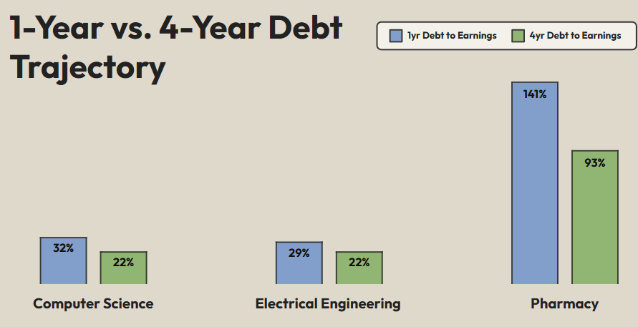
A high starting paycheck can give a false sense of security:
- High Starting Pay: Pharmacy graduates earn a high initial salary of $97,586.
- Huge Initial Debt Burden: Average debt reaches $130,992, leading to a 141% debt-to-earnings ratio in Year 1.
- 4x Debt Burden: Pharmacy graduates carry 4 times higher initial debt ratios than engineering majors.
- Long-Term Debt Pressure: By Year 4, the debt ratio remains high at 93%.
- Stagnant Industry Growth: Projected job expansion is below 5%, limiting long-term career growth.

6. Looking Ahead: Industry Growth Projections
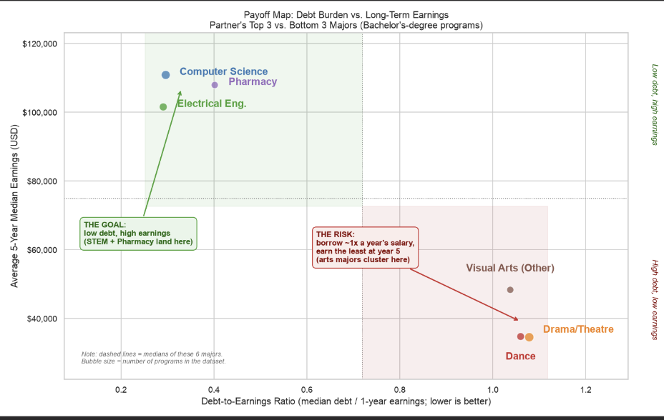Degree value depends heavily on future job demand through 2034:
- High-Growth Majors (> 15% Expansion):
  - Statistics
  - Public Policy Analysis
  - Mathematics and Statistics (Other)
- Low-Growth Majors (< 5% Expansion):
  - Stagnant fields lead to higher competition and slower wage increases over time.

7. Final Recommendations
- Optimal Pathways (STEM): Computer Science and Engineering offer strong starting pay ($77k–$83k), fast career growth, and manageable 22% 4-year debt ratios.
- Avoid Salary Traps: Always evaluate total student debt alongside starting pay before assuming a degree is financially safe.
- Understand High-Risk Degrees: Performing arts majors take on heavy early debt ($76k–$80k) relative to low starting pay ($22k–$26k).
- Remember Human Factors: While data reveals financial odds, individual networking, skill acquisition, and hard work remain vital for long-term success.

